

**MIDDLE EAST TECHNICAL UNIVERSITY**

**DEPARTMENT OF ELECTRICAL & ELECTRONICS ENGINEERING**

**EE 463- Static Power Conversion I - Hardware Project**

**DC Motor Drive**

**Simulation Report**

*Prepared for Assoc. Prof. Ozan KEYSAN*

**Tuğçe Şevval Kaya -**

**Zehra Güneş - 2232023**

**Kubilay Kaya - 2304905**

**Table of Contents**

Topology Selection 3

Thyristor Rectifiers 3

Single Phase Thyristor Rectifiers 3

Advantages 3

Disadvantages 3

Three Phase Thyristor Rectifiers 3

Advantages 4

Disadvantages 4

Three Phase Diode Rectifier & Buck Converters 4

Advantages 4

Disadvantages 4

Why Diode Rectifier & Buck Converters 4

Analytical Calculation 4

Buck Converter Design 5

On state 5

Off state 5

Voltage Ripple for the Buck Converter 7

Rectifier Design 8

555 Timer Calculations 8

Simulation 10

3-Phase Diode Rectifier: 10

A555 Controller 11

Buck Converter 13

IGBT 13

Gate Driver 14

Buck-Converter Diode 16

DC Machine: 17

For 0.2 Duty Cycle Output Values 17

For 0.8 Duty Cycle Output Values 18

Additional Simulation 19

Component Selection 19

Rectifier Diode 20

Timer 20

IGBT 20

Freewheeling Diode 21

Capacitor & Resistor 22

Fuse 22

Gate Driver 22

Heat Sink 22

Thermal Calculations 22

IGBT 22

Thermal circuit for IGBT 24

Diodes 24

Rectifier Three-Phase Diode Losses 24

Buck Converter Diode Losses 24

Implementation 25

Conclusion 25

**Introduction & Specification**

# **Topology Selection**

## Thyristor Rectifiers

### Single Phase Thyristor Rectifiers

#### Advantages

* It contains less circuit elements compared to other topologies.
* Less cost.

#### Disadvantages

* High Ripple Voltage.
* Needs a suitable firing angle. Therefore, controlling the thyristor rectifier is harder than the diode rectifier & buck converter topology.
* In order to minimize the ripple voltage, larger capacitors are needed. Therefore, it leads to unnecessary costs.
* Its true power factor is too small compared to the other topologies since it has higher THD value. THD of input current is not suitable for our applications.
* It is not proper for high voltages.

### Three Phase Thyristor Rectifiers

#### Advantages

* It has less ripple voltage compared to single phase thyristor rectifiers.
* Since the ripple voltage is smaller, the average DC voltage is higher than the single-phase thyristor rectifier.
* It needs a smaller capacitor since the ripple voltage is less.
* Can reach 1.35 times of input line-line voltage.

#### Disadvantages

* More complicated structure.
* The gate control is harder than the single-phase thyristor rectifier.
* It needs more circuit equipment; therefore cost is higher.
* The power factor is still small due to the THD of the input current.

## Three Phase Diode Rectifier & Buck Converters

#### Advantages

* Controlling is easy compared to thyristor rectifiers.
* Using a bridge rectifier, it is more compact.
* Can reach 1.35 times of input line-line voltage.

#### Disadvantages

* In order to minimize inrush current, an inductor should be added to the circuit.
* Its cost is high since the buck converter is the switching equipment. (IGBS, MOSFET etc.)

## Why Diode Rectifier & Buck Converters

We choose 3-phase diode rectifier and buck converter topology in order to drive the DC machine because of these reasons:

* Constructing a diode rectifier is easier than other topologies.
* Constructing a buck converter is cheaper than other topologies since the DC machine already provides the necessary inductor, capacitor, and resistors.
* By using a 555 timer, we can control the buck converter’s switch gate. This is more harder in thyristor rectifiers.

# **Analytical Calculation**

## Buck Converter Design

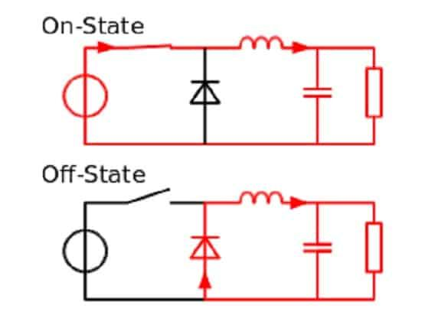

*Basic circuit model of a buck converter at on and off states in CCM*

#### On state

#### Off state

*Voltage and current waveform models of the buck converter*

Since our motor input (Vo) should be smaller than given 180 V maximum level,

Due to nonideal performance conditions, having 1 or 0 duty cycle is not easy to satisfy. Thus,

Hence, we can define a condition for the input voltage of the buck converter as

*Throughout the function of the buck converter, we also estimated the minimum inductance value to stay in*

*Continuous Current Mode*

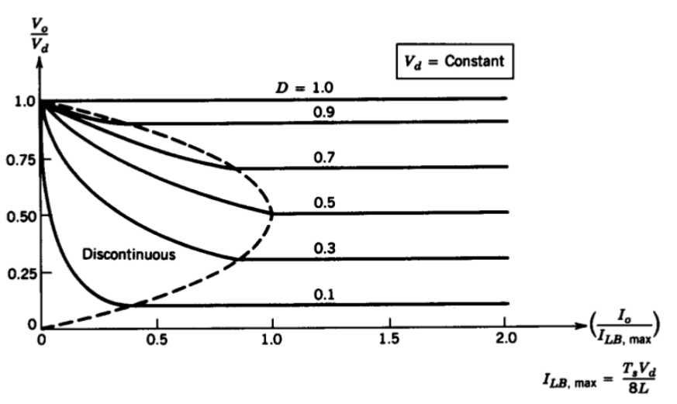

*Output voltage and current relations at Continuous and Discontinuous Conduction Modes*

As it can be observed, the critical current value occurs when D = 0.5

Foer our case D = 0.5, by given armature impedance of the motor and assuming our frequency range 1-5 kHz it is obtained that

Meaning that throughout our duty cycle choices, even if we do not implement an additional inductor since there is already an inertial inductance of the motor, which is higher than 0.2 mH, we will be in a safe zone for the continuous conduction mode.

#### Voltage Ripple for the Buck Converter

By using off time ratio (1-D) it is obtained that

For worst case scenario, by taking as

At this point, increasing the frequency or implementing an extremely high capacitor would have been expected as possible solutions. However, increasing the frequency means also increasing the switching losses, which can be found in the thermal analysis part, and it can disturb the thermal limit of our components. Moreover, a small capacitance will not be enough to obtain a reasonable ripple range, much higher value can balance that, yet this will cause higher cost and sizes in our design which may not be applicable under experimental conditions. Thus, it is currently considered that the internal capacitance of the motor will satisfy our conditions. Besides, if it seems necessary during test periods, by choosing 3.3 µF capacitor will be placed.

Hence the ripple is obtained as

which can be accepted as small in the range of our motor input.

## Rectifier Design

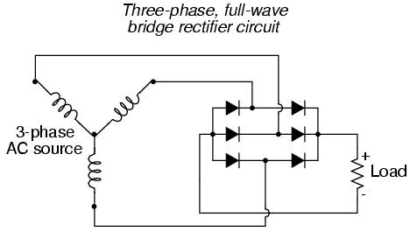

*The circuit connection model of three phase full bridge rectifier design*

As it was found previously on the buck converter design part that

Since the input voltage of the buck converter is supplied by the output voltage of the rectifier,

By Yn configuration, the necessary input voltage for the rectifier can be estimated as

## 

## 

## 

## 555 Timer Calculations

Basic 555 timer structure,

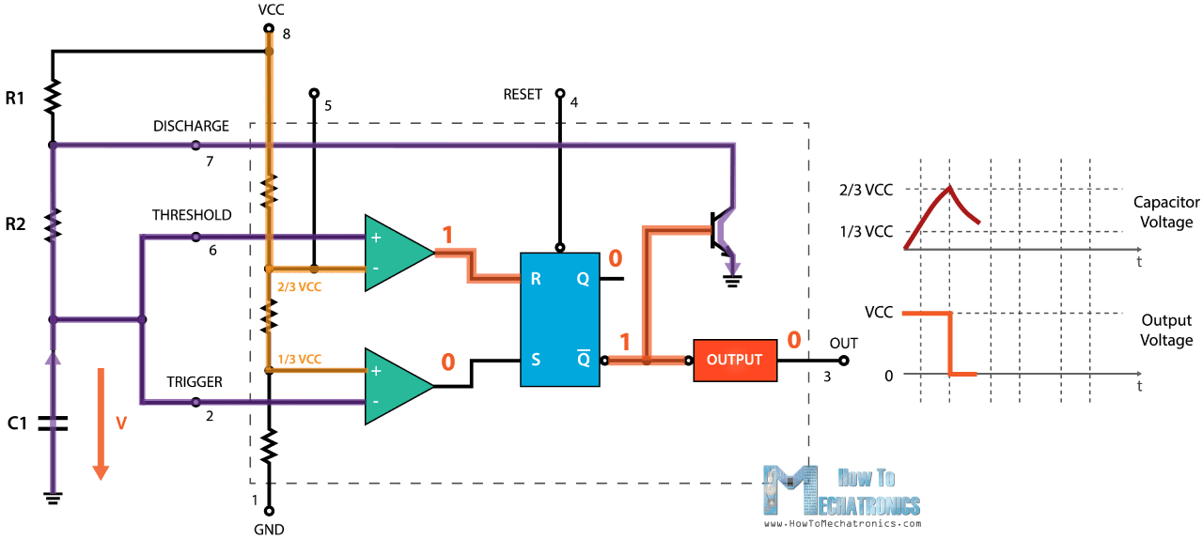

Formulas,

In order to create adjustable PWM, we add this configuration to the diodes and POTs via the charging and discharging paths.

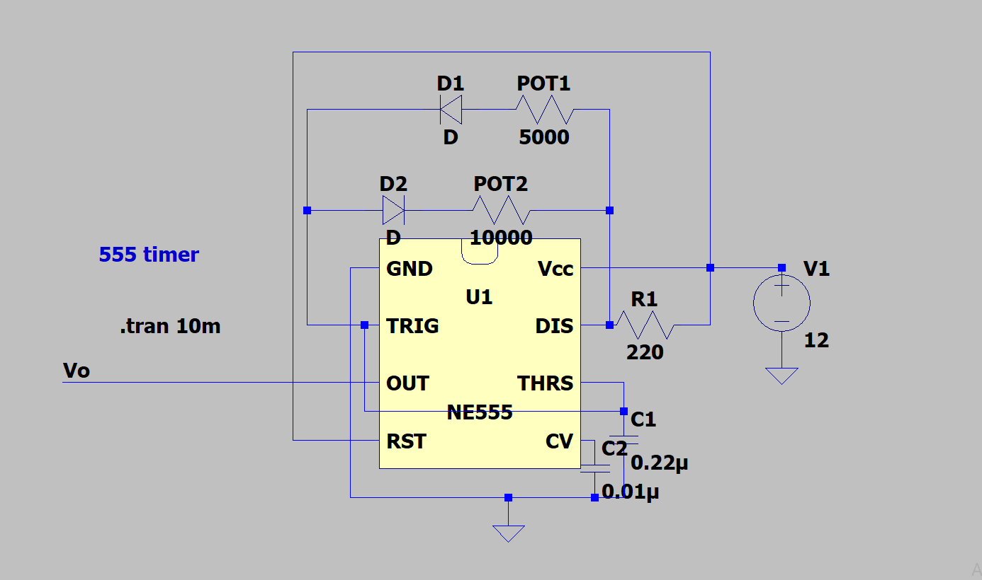

Calculations,

We have used 5kΩ and 10kΩ resistance respectively for POT1 and POT2. In real, POT1 is changing between 1.6Ω and 4.8k Ω and POT2 is changing between 2.8Ω and 9.6kΩ. Then,

PWM maximum,

98%

PWM minimum,

2.1%

Although we could reach these PWM values, we have to stay away from the boundary points of PWM. This is because at the near 0% and 100% PWM values, the switch (IGBT) cannot be operated properly since it has a switching time interval of ON and OFF times, PWM is not enough to compensate for it. Therefore, we changed R1 with 1kΩ and we have adjusted PWM between 17% and 85%. By the same steps,

PWM maximum,

85%

PWM minimum,

17%

As seen from obtained results, the operating frequency is around 1kHz, so we decide to use IGBT as a switch. The performance of IGBT is greater than MOSFETs and other switches at low frequencies. Also, the current rating of IGBTs can reach up to 1kA.

# **Simulation**

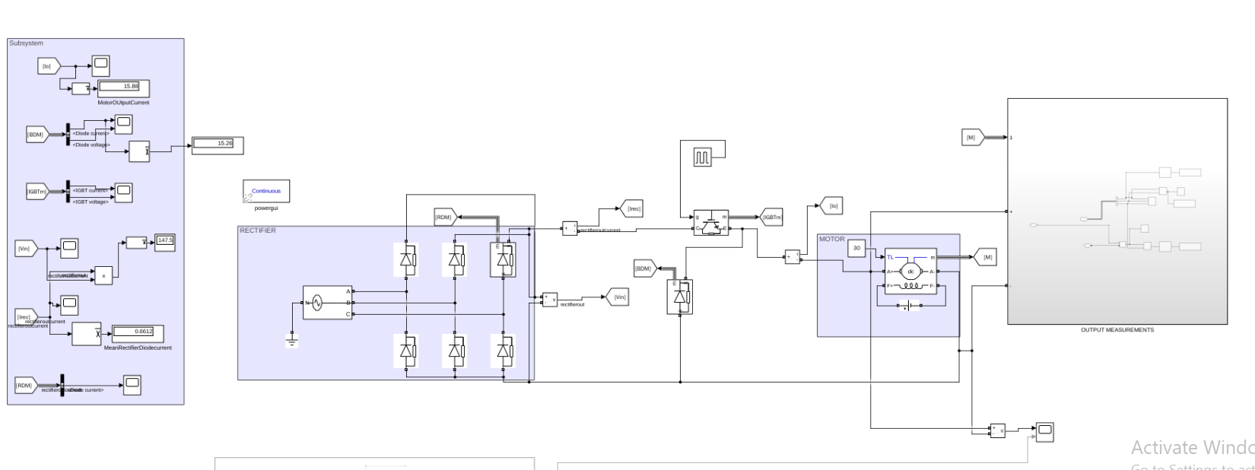

## 3-Phase Diode Rectifier:

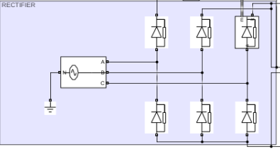

Rectifier diode current and voltage waveforms,

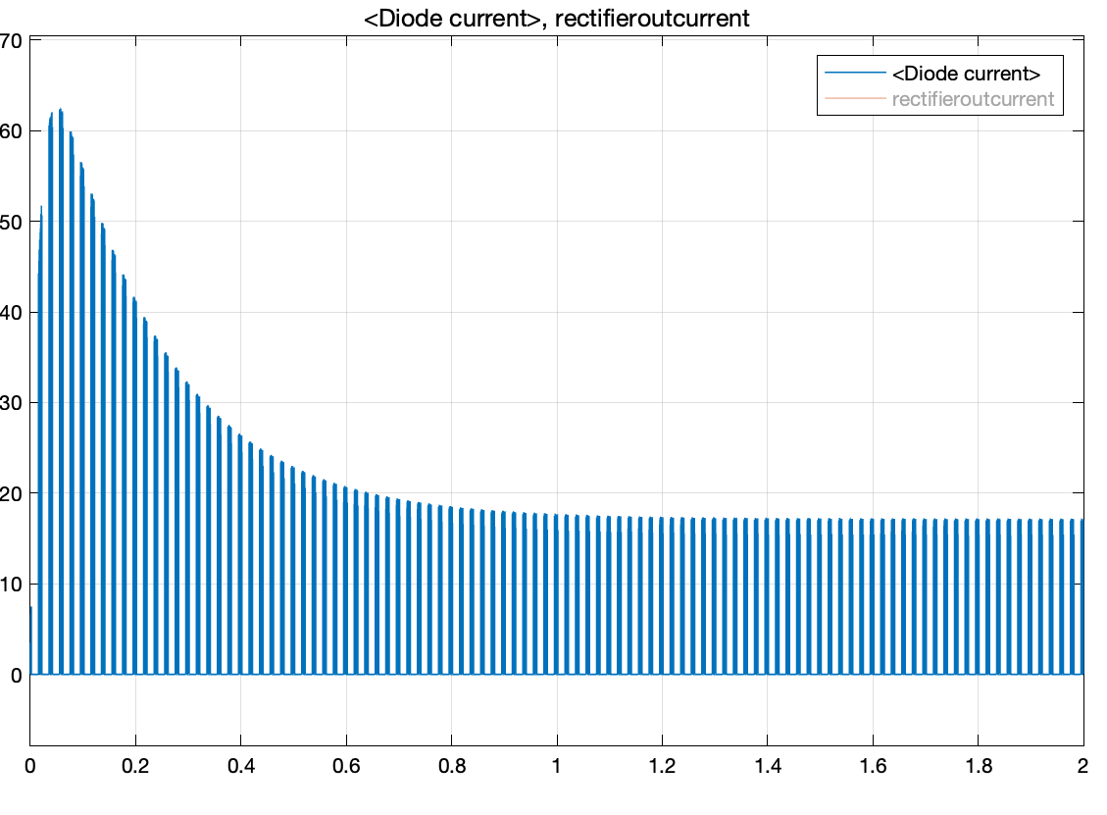

The graph which can be seen above shows the diode’s starting current if we set the initial duty cycle as 0.2. However, since we don’t know the line impedance, we didn’t add any value to our simulation. Therefore, we expect that less inrush current will be measured in laboratory conditions. Another factor of high starting current is the stationary motor. When the motor is stationary, armature voltage is equal to zero. Then, when we supply voltage to the DC machine, the high current is passing thoruogh armatures. This becomes very problematic since it can damage the circuit. Therefore, we still try to stabilize the armature current for soft-starting.

## A555 Controller

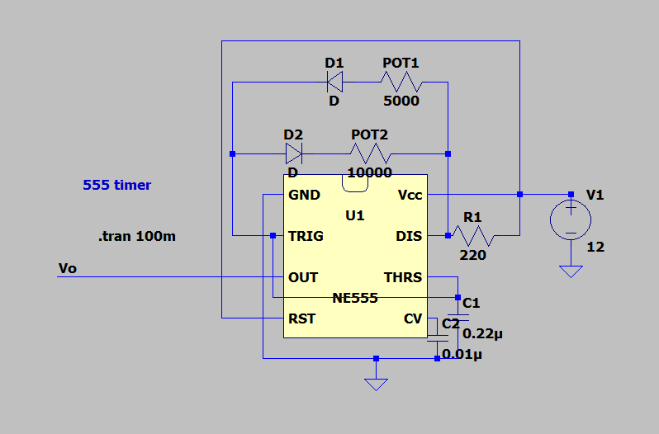

Maximum duty cycle case,

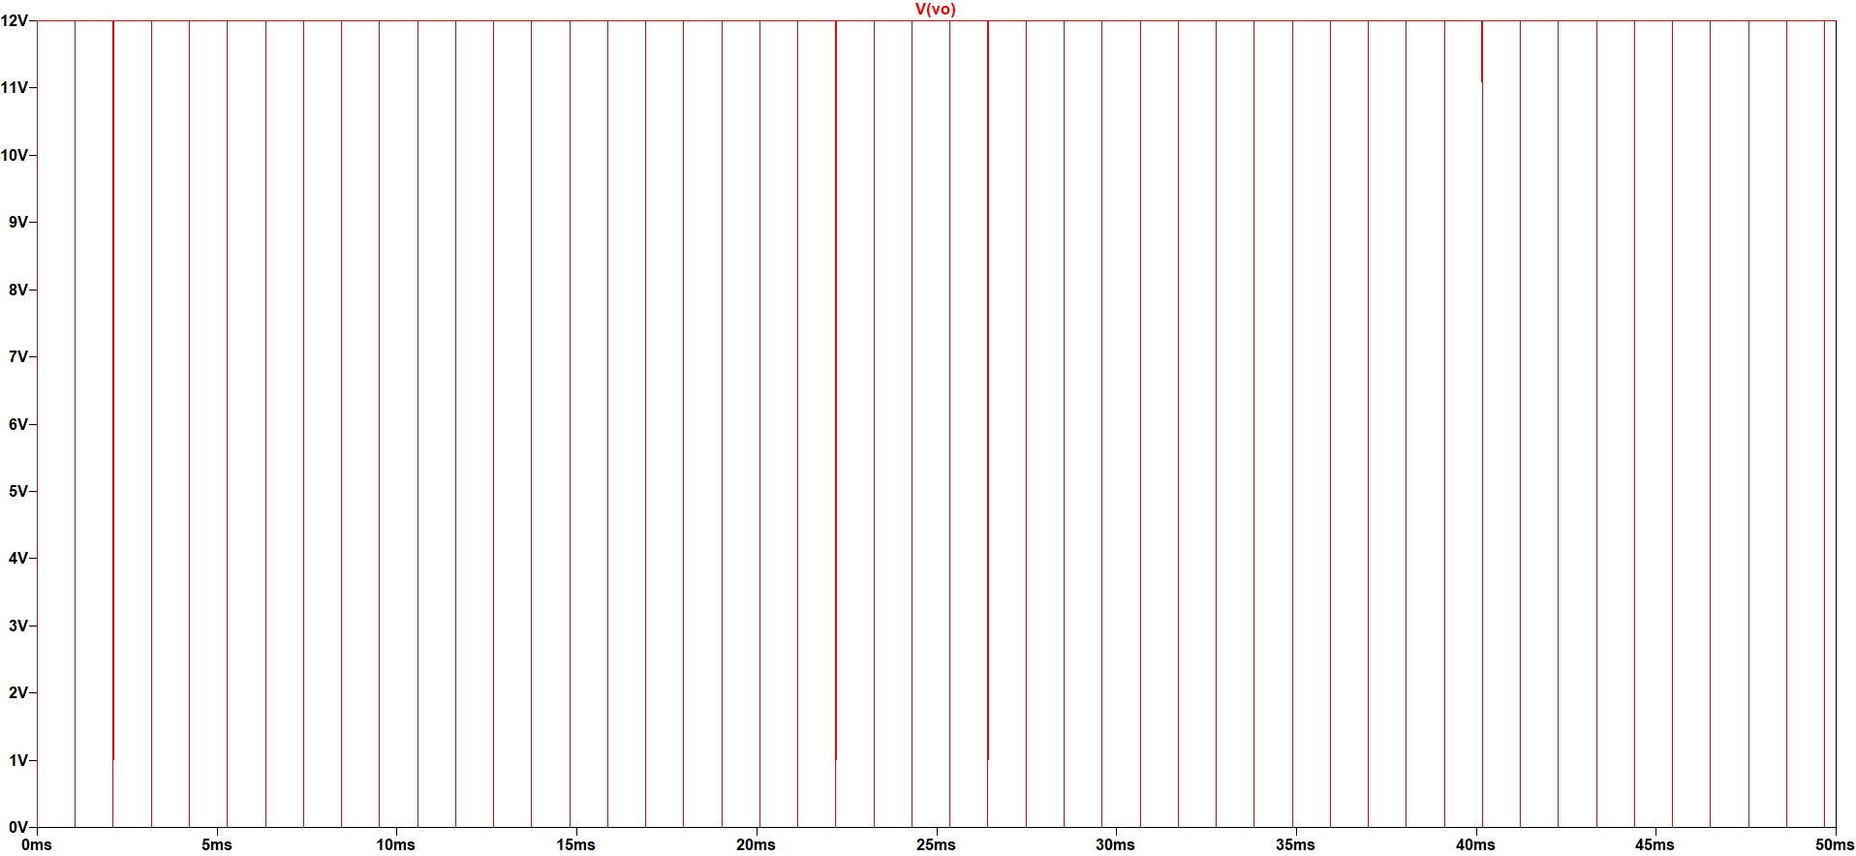

Minimum duty cycle case,

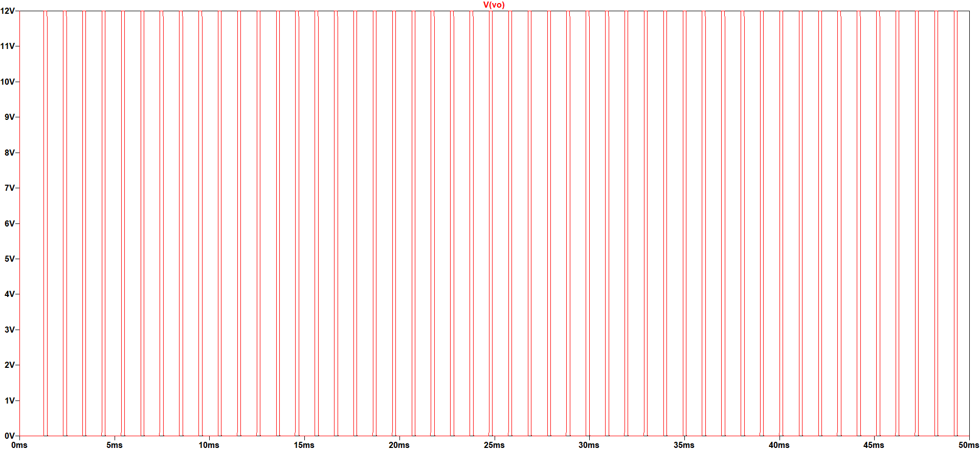

According to our research, we see that the most convenient way to control the buck converter is using the ASTABLE 555 Timer circuit. An Astable timer can be controlled just by using POTs.

The most crucial advantage of this timer is changing duty cycle easily. However, the frequency changes according to the resistor values that we change. Therefore, it may be a disadvantage. On the other hand, we are using an IGBT for buck converter and it is proper for the 1-5kHz interval. Therefore, we calculated the resistance of the timer to work between these frequency intervals.

In the timer circuit above, R1 & R2 values determine the frequency and the duty cycle of the circuit. We are planning to change both R1 & R2 during our project. The related formulations and description can be seen in the “Analytical Calculation” part.

## Buck Converter

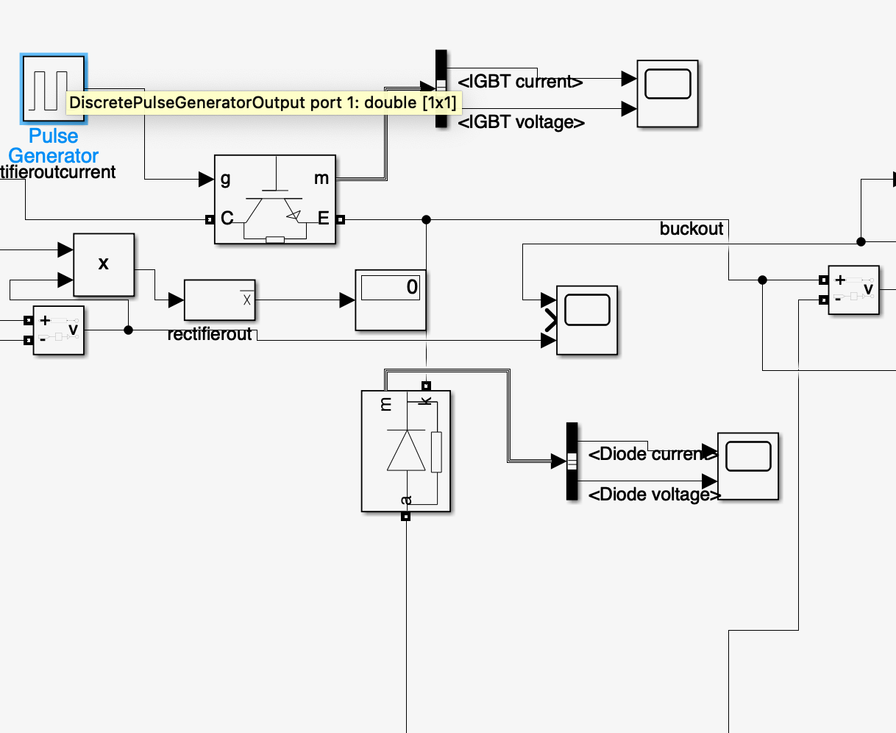

Here we see the buck converter part. As can be seen, we didn’t connect any capacitor, inductor, and resistance because the DC motor already provides these components’ characteristics. On the other hand, in case of any necessities, we also bought some capacitors to provide better dc voltage at the input terminal of the DC machine.

#### IGBT

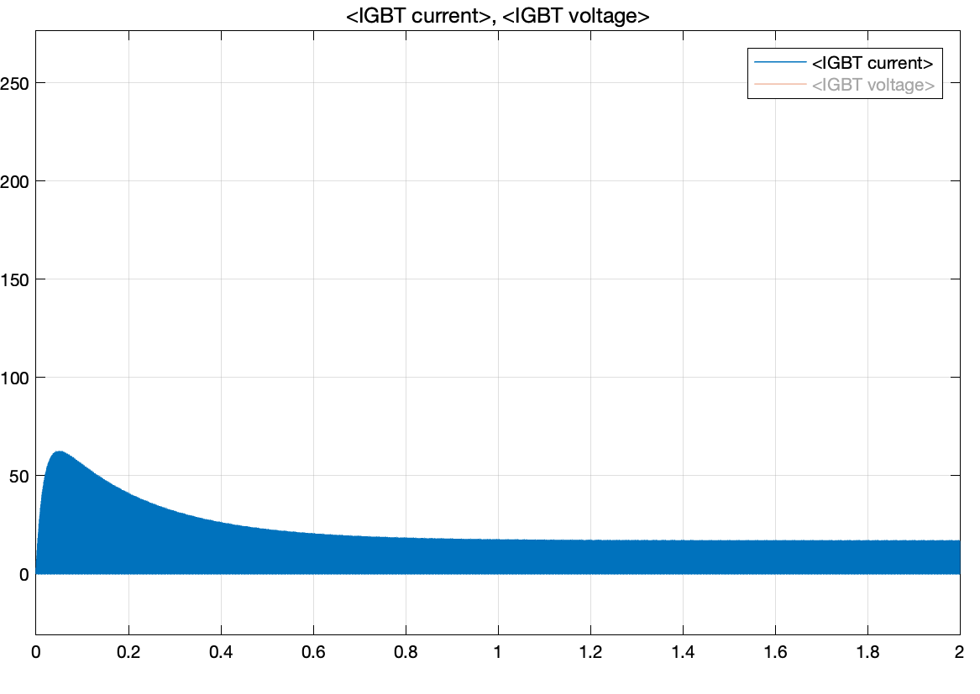

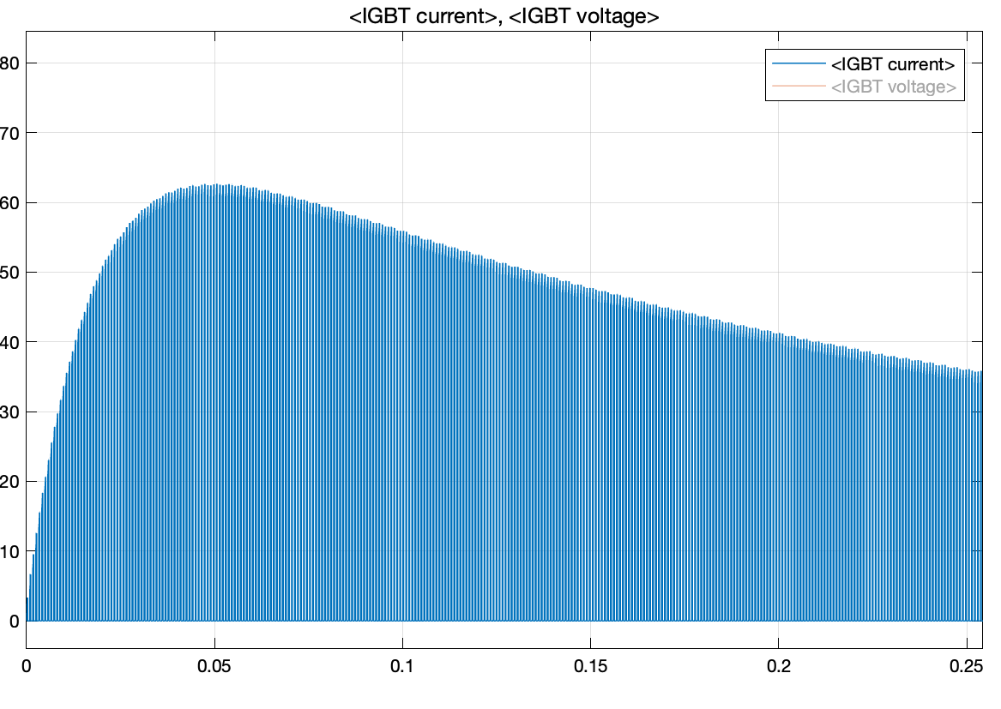

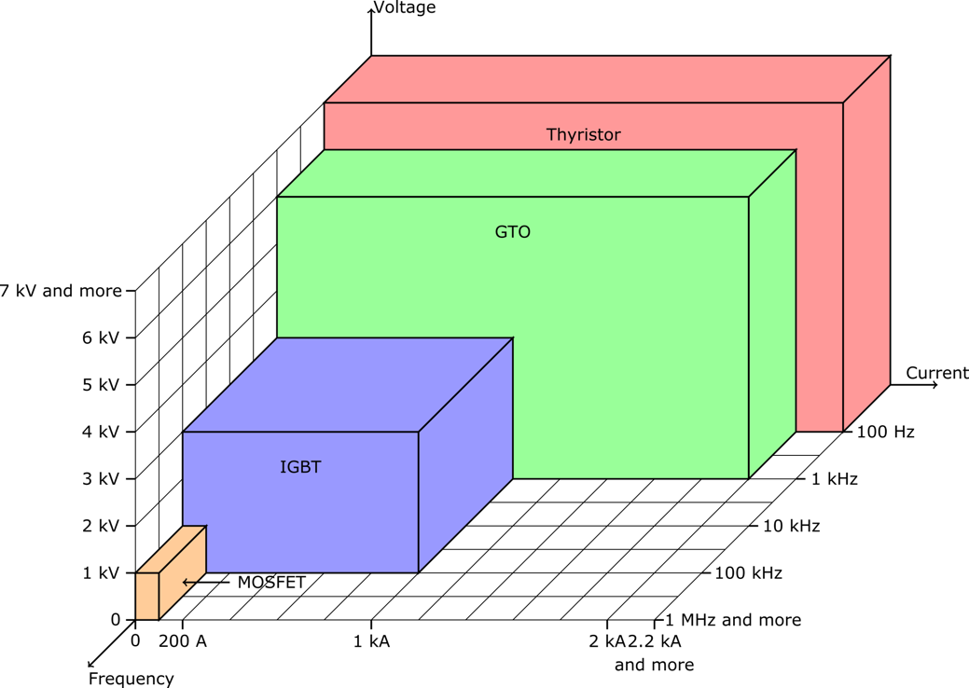

In our design, we did a selection between MOSFET and IGBT. Since IGBT can work at low frequency and operates at high current values, we choose the IGBT as a switching device. Above, the steady state and starting currents of IGBT for 0.2 duty cycle can be seen. As can be seen, the starting current is relatively high. However, as mentioned in previous parts, we didn’t add any inductor to the source side. Therefore, the inrush current at start up occurs. Also, in this case, the motor’s initial speed is zero. During the demo, since we set an initial voltage by using variac, we expect that this high current will not occur, and we will not observe any problem.

#### Gate Driver

By using a gate driver we have tried to operate IGBT properly without exceeding rating values. When we do not use a gate driver, the gate-emitter value can reach very high values. However, the rating value of gate-emitteer voltage is about 20V for most IGBTs. Therfore, the gate driver provides the same duty cycle to the IGBT by keeping it in a safe region.

Design schematic of gate driver,

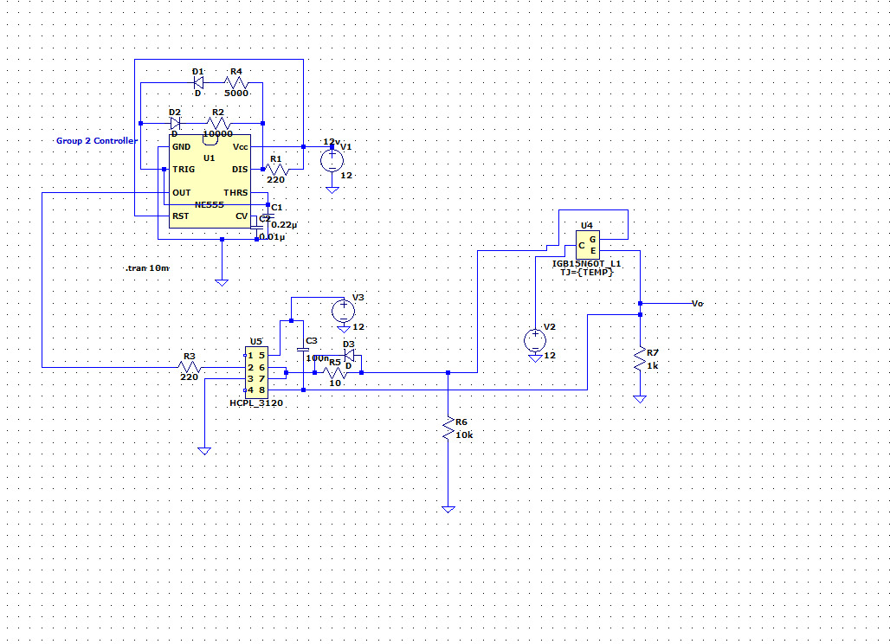

Output pwm obtained from 555 timer,

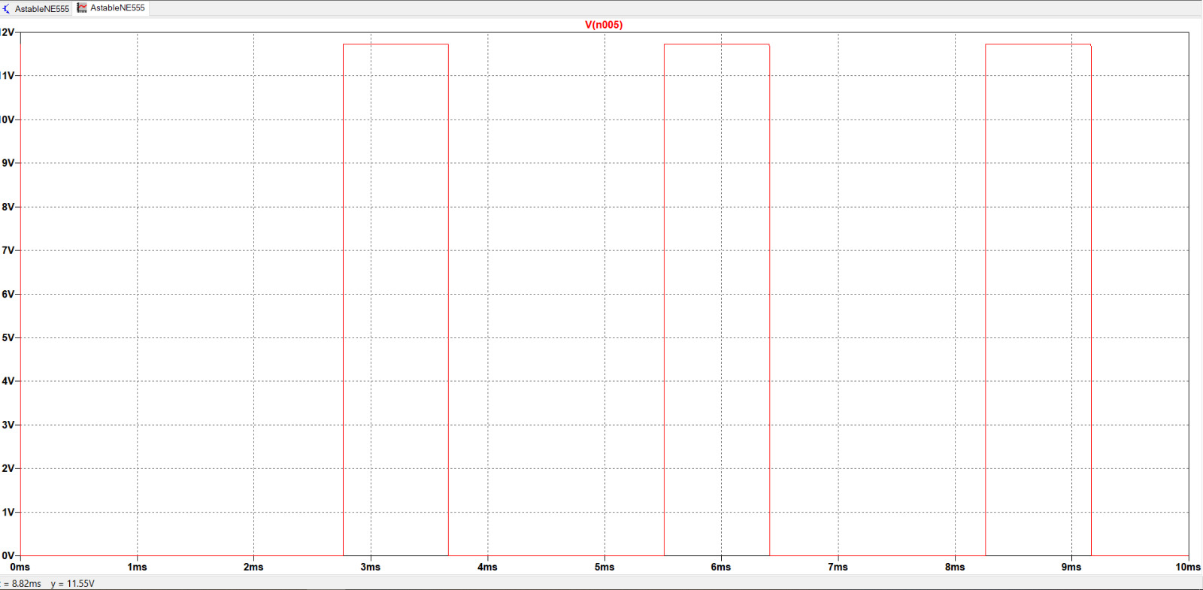

Output emitter voltage of IGBT,

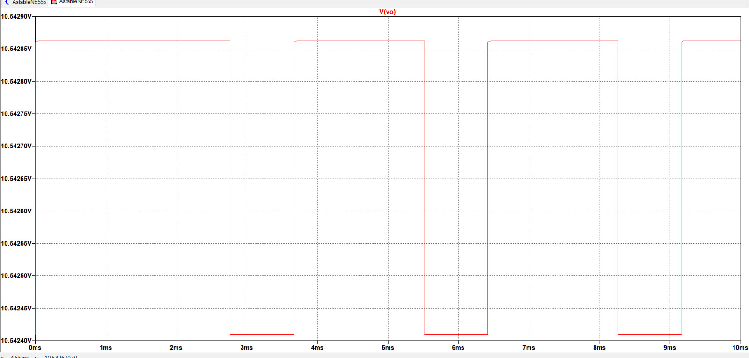

As seen from the figures, output voltage is a complement of PWM. In order to solve this problem, we decided to add the transistor to the input of the gate driver(pin 1 and 2). The transistor behaves like an inverter and when PWM is high, it gives output low and vice versa. Therefore, input PWM is inverted by transistor and output emitter voltage has a similar shape with the PWM obtained by 555 timer.

#### Buck-Converter Diode

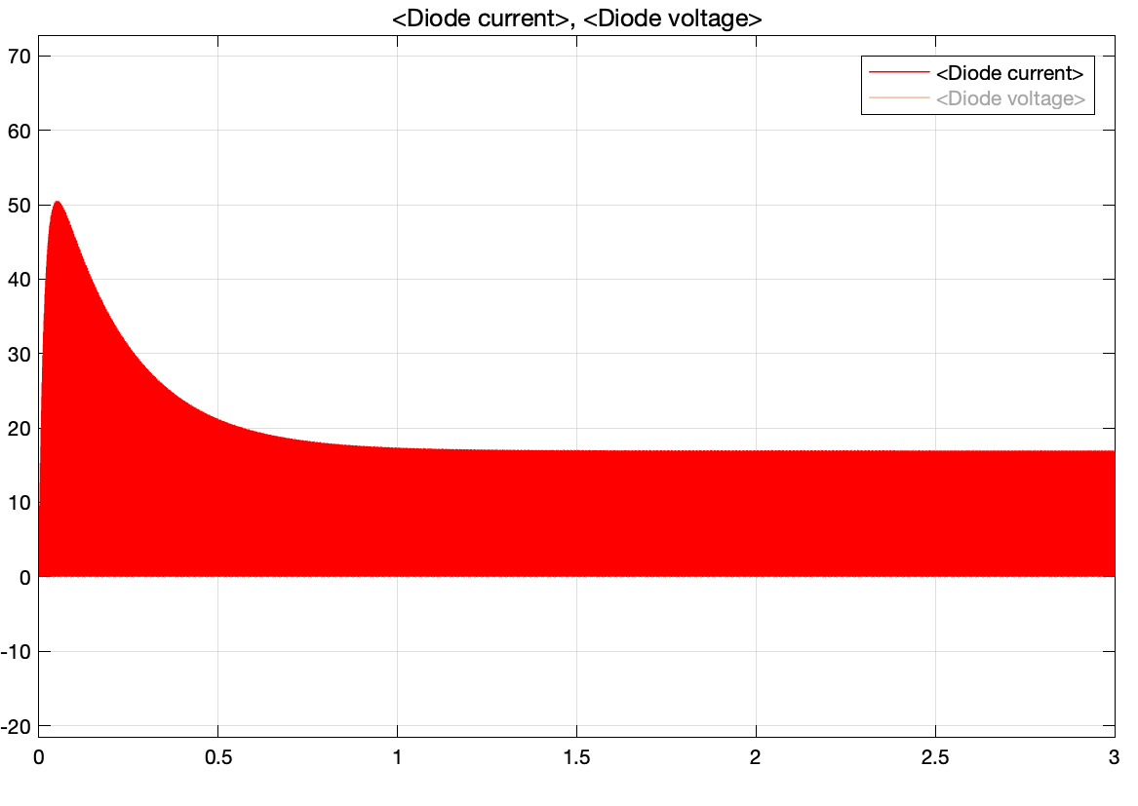

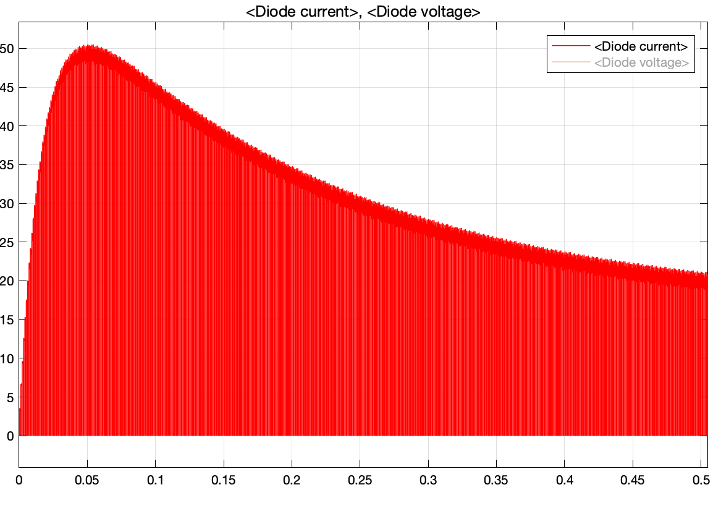

When the duty cycle of a buck converter is low, the mean current passing through the diode is high.). We measure the mean current is about 20A at duty cycle 20%. Therefore, we have choosen a diode accordingly. The details can be seen at the component selection part.

## DC Machine:

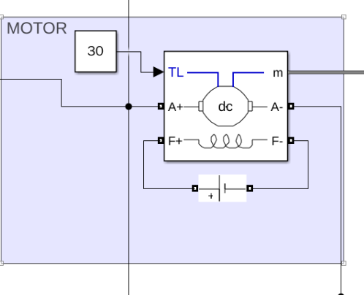

### For 0.2 Duty Cycle Output Values

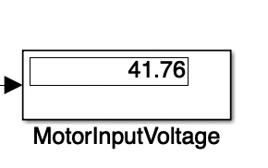

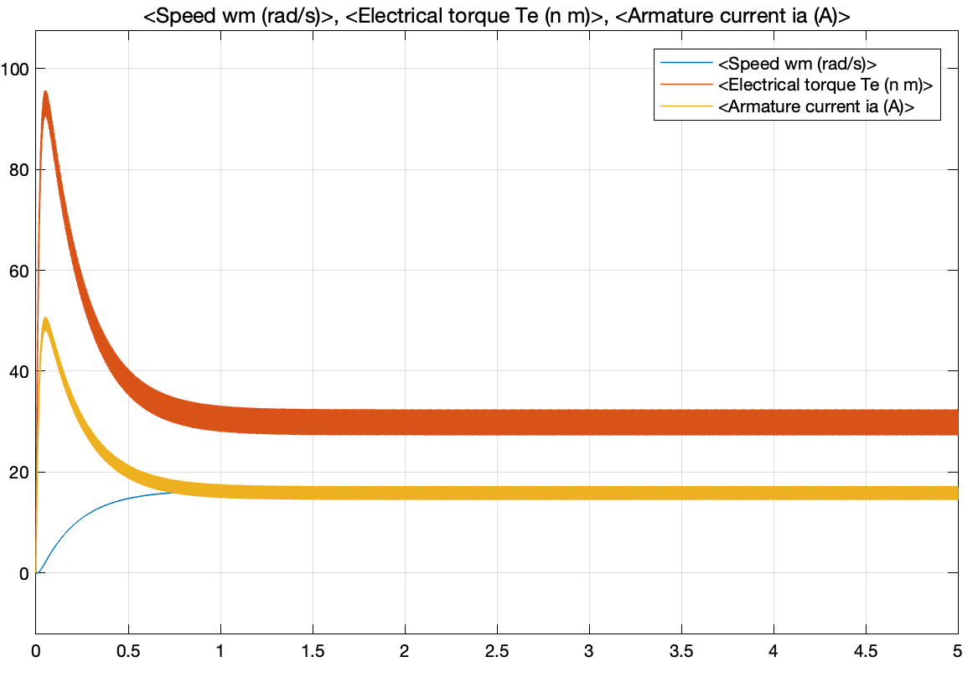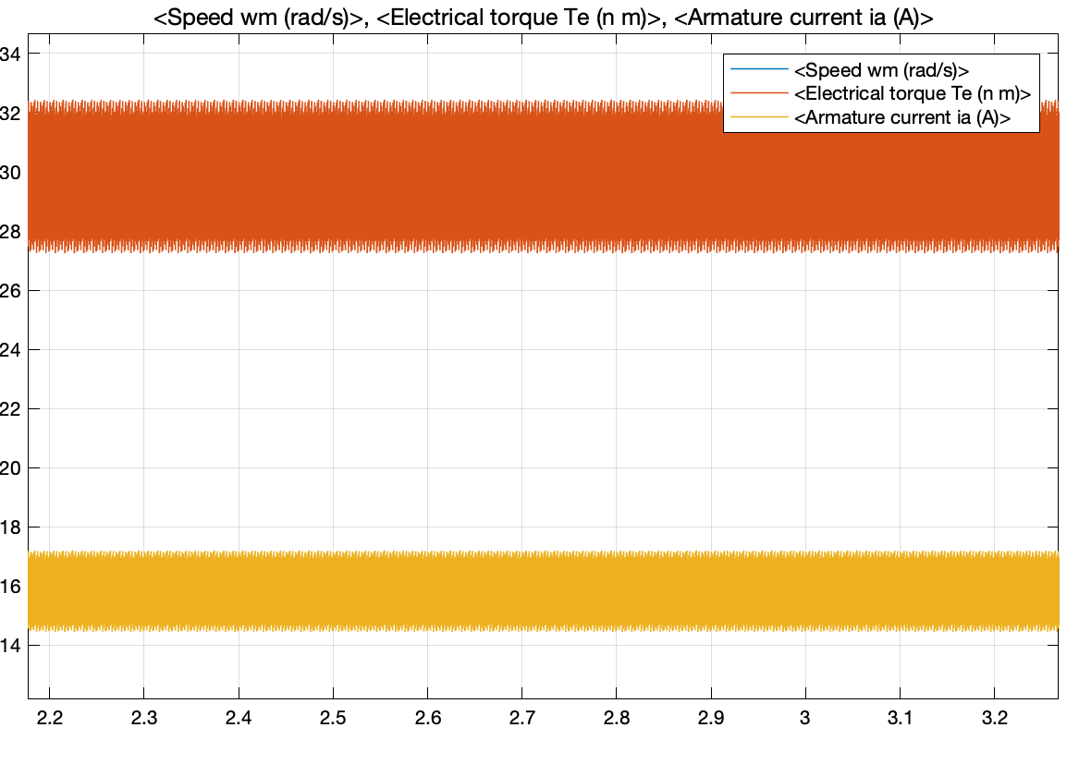

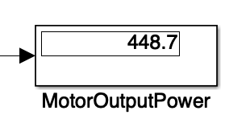

### For 0.8 Duty Cycle Output Values

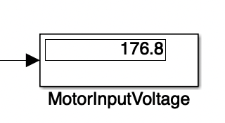

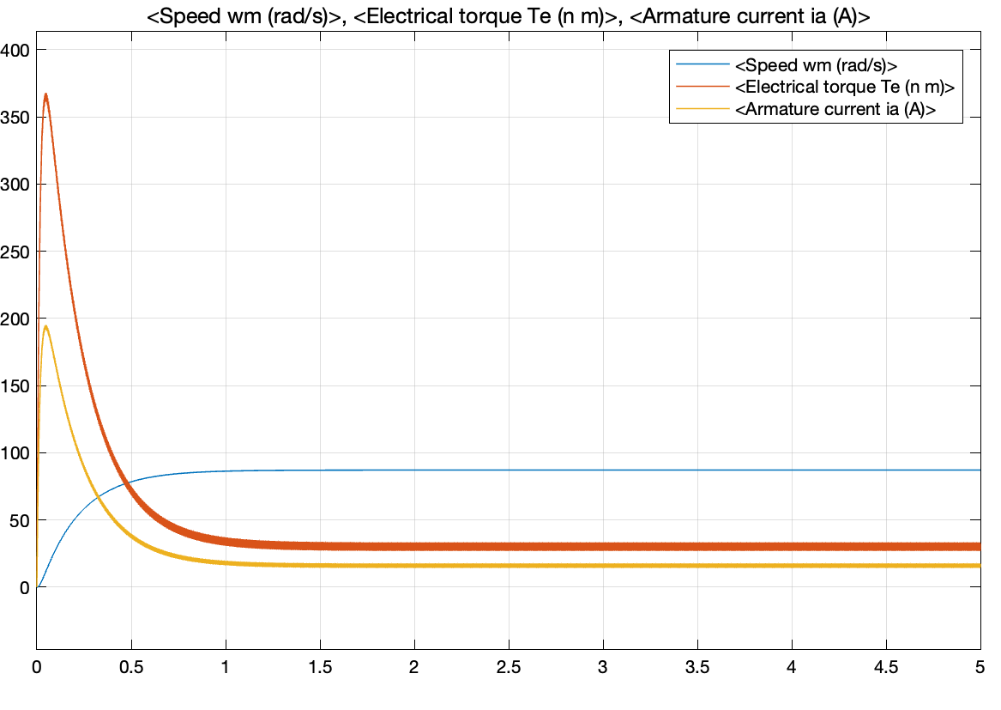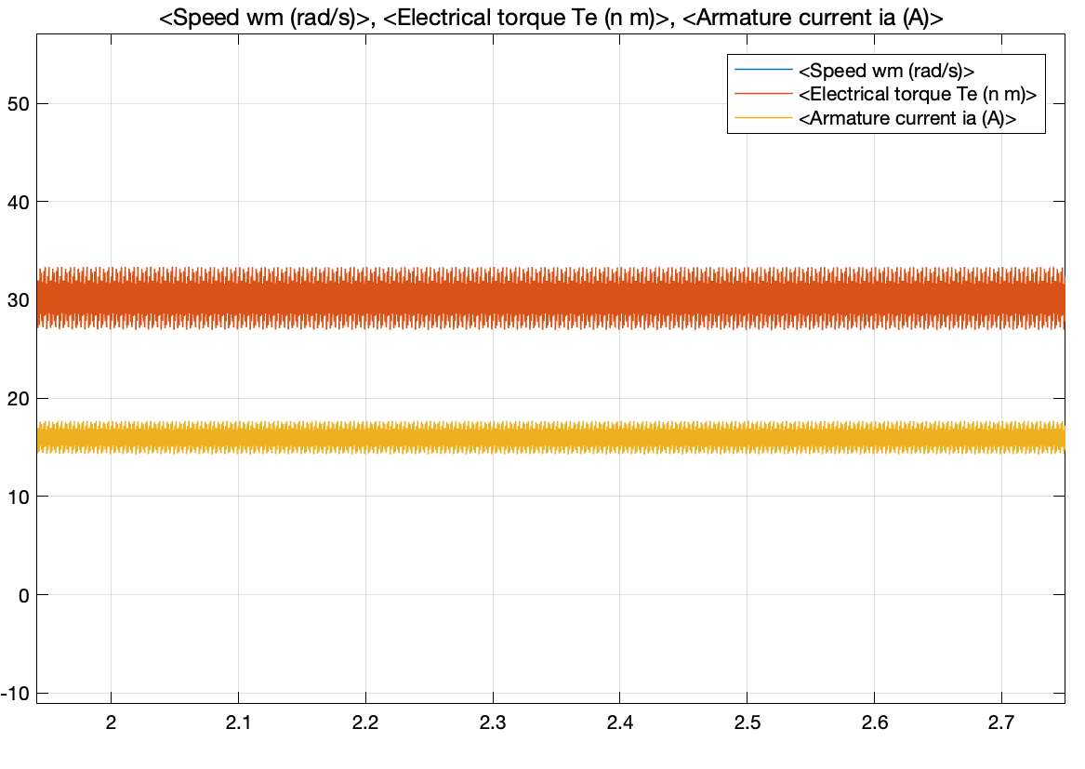

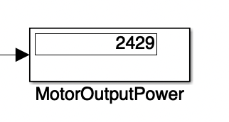

Since we don’t want to reach the edges of 0 and 1, we determined the use 0.2-0.8 duty cycle values at min and max. Therefore, we added the related simulation results for the DC machine as can be seen above. Here, we see that only speed is changing when duty cycle is changed.The steady current is about 16A and this value meets our requirements. Also, we see a high inrush current for the 0.8 duty cycle. Since the motor speed is zero at the start-up, this inrush current is normal. In our demo day, we are allowed to do soft start using variac. Therefore, we expect that there is no high inrush currents observed.

## Additional Simulation

We also obtain the duty-cycle vs. Torque-Current-Speed graph. If we will change the duty cycle %15 at each second, the Torque, Current, Speed vs time graph can be observed like that:

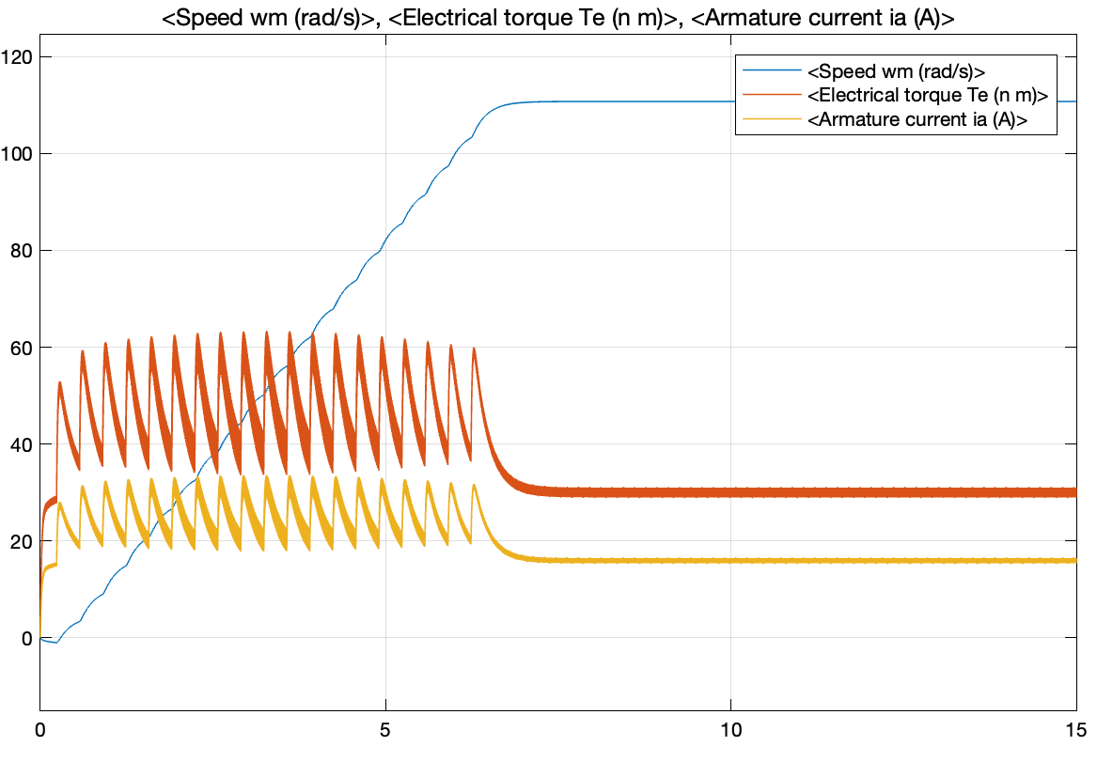

# Component Selection

|  |  |  |  |  |
| --- | --- | --- | --- | --- |
| **Component** | **Manufacturer Number** | **Quantity** | **Price(₺)** | **Total Price(₺)** |
| **Three phase bridge diode** | SKBPC5016 | 1 | 38.5 | 38.5 |
| **Timer** | NE555P DNSX19 | 1 | 2.6 | 2.6 |
| **IGBT** | IXGH24N60C4D1 | 1 | 36.45 | 36.45 |
| **Diode** | DSEI30-06A | 1 | 40.03 | 40.03 |
| **Transistor** | BC308B | 1 | 1.33 | 1.33 |
| **Gate Driver** | HCPL-3120 | 1 | 22.67 | 22.67 |
| **Fuses(30A 6*30mm ceramic fuse )** | - | 5 | 2.66 | 13.33 |
| **Capacitor(3.3uF 50V ceramic capacitor)** | - | 1 | 0.888 | 0.888 |
| **Capacitor(220nF 630Vdc)** | - | 1 | 1.13 | 1.13 |
| **Capacitor(10nF 50V ceramic capacitor)** | - | 1 | 0.752 | 0 |

## Rectifier Diode

**SKBPC5016 50A 1600V Three phase bridge diode**

|  |  |
| --- | --- |
| PEAK REPETITIVE REVERSE VOLTAGE | 1600V |
| AVERAGE RECTIFIED FORWARD CURRENT | 50A |
| PEAK REVERSE CURRENT | 10uA |
| NON-REPETITIVE PEAK SURGE CURRENT | 500A |
| FORWARD VOLTAGE(IFM=17A) | 1.2V |

According to our simulations and calculations, we see that we need a diode which can carry at least 30A. Since three-phase bridge diodes are cheaper than 6 diodes and they have a smaller size, we choose 3phase bridge rectifier diode. It can carry 50A for 1600V.

## Timer

**NE555P DNSX19**

Since we generate a PWM by using only capacitors and resistors, we choose the NE555 Timer. This timer can generate PWM from microsecond to hour intervals. We will generate 1-5kHz square waves in our circuit.

## IGBT

**IXGH24N60C4D1 N Channel IGBT Transistor 30A 600V**

|  |  |
| --- | --- |
| *COLLECTOR-EMITTER VOLTAGE* | *600V* |
| *GATE-EMITTER VOLTAGE* | *+/- 20V* |
| *COLLECTOR CURRENT* | *49A @ 25°* |
| *POWER DISSAPATION* | *187W* |
| *OPERATING TEMPERATURE* | *-55° / +150°* |

We calculated and measured that we will use at most 25A in our circuit at the steady state. Since the range of MOSFETs are not enough, we will use IGBT in our circuits. In our research, we couldn’t find an IGBT that has higher current capability than **IXGH24N60C4D1.** Therefore, we decided to use this IGBT which also exists in the laboratory.

## 

## 

## Freewheeling Diode

**DSEI30-06A 37A 600V 35ns Ultrafast Diode**

|  |  |
| --- | --- |
| RATED REPETITIVE REVERSE VOLTAGE | 600V |
| AVERAGE RECTIFIED FORWARD CURRENT | 37A |
| MAXIMUM REVERSE CURRENT | 50uA |
| FORWARD VOLTAGE | 1.6V |
| REVERSE RECOVERY TIME | 50ns |

For low duty cycles, the current through the buck converter’s diode increases. Therefore, we have chosen the diode with the current rate accordingly. Also, since its recovery time is small, we eliminate the switching losses.

## Capacitor & Resistor

We bought different capacitors and resistors for different purposes. Since we will use these capacitors in our controller, we don’t focus on their voltage and power ratings. However, as we mentioned in previous parts, we bought some capacitors to connect the input terminals of the DC machine if it is needed. These capacitors are suitable for high voltage applications. Their voltage ratings are 400V.

## Fuse

**30A 6x30mm Ceramic Fuses**

According to our calculations and circuit element current rates, current value should not exceed some limits. In order to prevent damage in the circuit, we bought ceramic fuses.

## Gate Driver

**HCPL-3120 2.5 Amp Output Current IGBT Gate Drive Optocoupler**

In order to prevent high voltage drop on gate-emitter voltage of IGBT, we have added a gate driver to our design. The HCPL3120 has an insulation voltage of VIORM=630 Vpeak and it provides 2.5A to the gate of IGBT. These values are very high among other gate drivers and suitable for our design.

|  |  |
| --- | --- |
| MINIMUM PEAK OUTPUT CURRENT | 2A |
| INSULATION VOLTAGE | 630V |
| TEMPERATURE RANGE | 40-100*°C* |
| MAXIMUM SWITCHING SPEED | 500ns |

## 

## Heat Sink

## 

## 

## 

# Thermal Calculations

In analysis part, there are 5 components that should be considered in thermal view. These are three-phase rectifier unit, the timer unit, gate driver unit, IGBT which is aimed to be used as the switch, and buck converter diode. At our on-going stage for the project, the losses for timer and gate driver unit were hold since the prototype and more experimental measurements are presumably needed.

## IGBT

Over IGBT, there are 2 types of losses: switching losses and conduction losses. Switching losses are calculated by given section of the datasheet while taking into maximum frequency account:

For ON mode :

For OFF mode :

As maximum frequency was limited at 5 kHz,

Conduction losses can be calculated for IGBT by given section of the datasheet:

Overall, for our IGBT

### Thermal circuit for IGBT

*Typical thermal model in power electronics*

Ignoring the capacitances for steady state,



And

Overall,

Considering the changes in the parameters after 125 ,

## Diodes

### Rectifier Three-Phase Diode Losses

Conduction losses,

@25°C

Due to lack of data on datasheet, we could not calculate switching losses. (trr is not given). Also, we could not calculate temperature increase of diode since there is only value on datasheet.

### Buck Converter Diode Losses

Conduction losses,

@25°C

Switching loss,

@25°C

@125°C

For temperature increase of diode,

# Implementation

# Conclusion